**CMSC Project2 Report**

**Name: Xinyang Li**

**UID: 114104670**

**Team Members: Jiejia Ye, Yifan Yang**

In **ANMS part,** we use the given algorithm in order to get first N_best strong corners. For N_best, I choose it to be 400 at first. After plotting these 400 points on the picture, I got the following image:

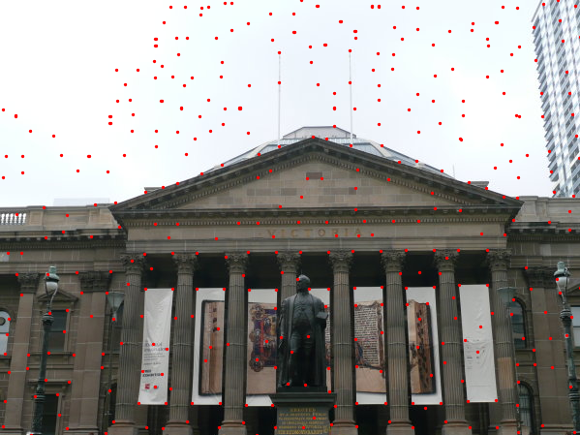

Then, for the **Feature Descriptors and Matching** part, we wrote two files of code, the first one is “FeatureDescriptor.m” and another one is called “FeatureMatching.m”. “FeatureDescriptor.m” aims to characterize every feature points (we found by ANMS) by a 64x1 vector. After finishing this step, we use “FeatureMatching.m” to match feature points we selected and characterized in two images. The image I get is this following image:

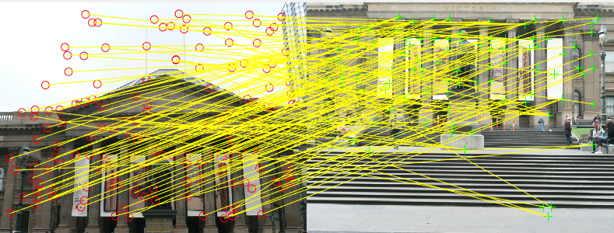

After feature matching, it is clear that there exist many bias. Many points in this two pictures did not seem to match perfectly. Therefore the **RANSAC and Homography Estimation part** is very necessary. As we did in project1, RANSAC is a way to rule out outliers based on normal distribution and possibilities. For this project, I choose threshold to be 100. After applying RANSAC, the matching between two pictures seemed to be perfect, even though not too much lines remaining. The output picture is this following:

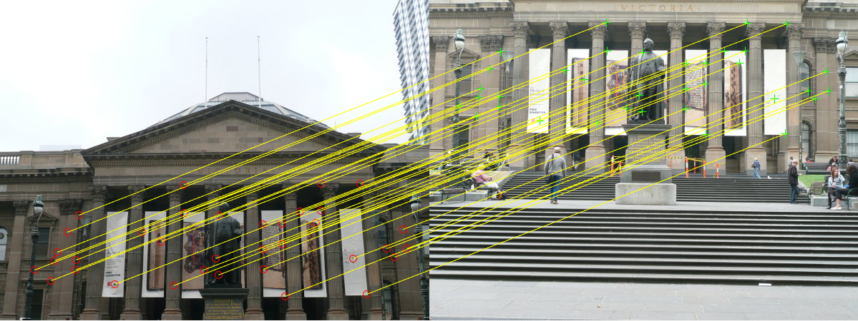

Finally, the last part is **Image Warping and Blending.** At the very beginning, I test for train images set1 and set2, both works fine in my program, except set3. When I apply my program to set3, it warned that images are too big to get good result. Therefore our team writes a “computeBlending” method, which can solve this problem.